**Let’s Code and Have Fun**

* **By Gautam Krishna M**

Q1) Create a Box model Just like the image which is given below :

Objective :

1.Each Box hight and width is 10rem

2.The out edges should be curved by 10px

3.Box 1 : colour – aquamarine , Box 2 - Coral , Box 3 – Cornflowerblue

4.The arrangement should be like the image given below

What you will learn :

Through this we can understand how to align items in centre and how align specific item in specific manner

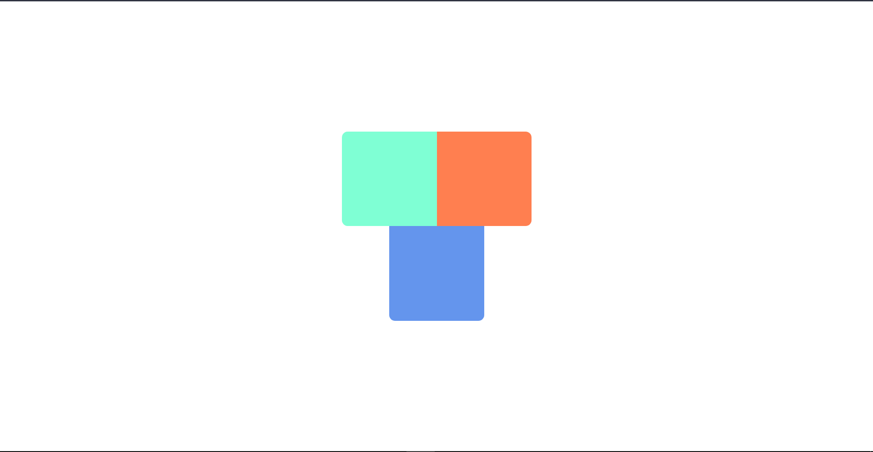

Q2) Eyes Open and Close Monkey:

**Objective :**

1.While Hovering The monkey should open eye

2.Title(Monkey Eye) should be centre and image also should be in Centre

3.Try to use div box (height : 10rem and width : 10rem) , place the monkey png image in this box

Open eye : <https://www.kindpng.com/picc/m/112-1128354_monkey-emoji-2-monkey-ears-emoji-emoticon.png>

Close eye : https://www.pinpng.com/pngs/m/119-1191783_monkey-sticker-hands-cover-eyes-emoji-hd-png.png

4.monkey should be in that position in the given image

**What you will learn :**

Through this we can understand how hovering Effect will work and How to fix an image in a div box and Know how Text align work

Q3) Nav Bar

Objective:

1. Create a Nav Bar According to the Gif Given below
2. Title Should be Right and Content of the Nav Bar should be in left
3. Margin between the content is 10px and padding for each Content is 10px
4. Height of Nav Bar is 10vh
5. Hovering effect also should be there with opacity of 0.6

What we can Learn :

Through this we can understand how to build a basic Nav bar with some functionalities, and also to play around with styles



Q4 ) Polaroid Film

Objective :

1. We wanted to make a polaroid Film just like the image given below
2. You can add any title you want
3. Film need to place in centre of the page
4. Hight of the film : 50vh and width: 20%

What we can Learn :   
 Through this we can design a simple Polaroid Film Style image

